

**YEAR: 9**

**SUBJECT: SCIENCE**

**TEST: Plate Tectonics**

**TIME: 45 mins**

**QUESTIONS: Part A: Multiple Choice Questions (10 marks)**

**Part B: Short Answer Questions (24 marks)**

**TOTAL MARKS: 34 marks**

**DO NOT WRITE ON OR MARK THIS PAPER**

**SECTION ONE: Multiple Choice Questions (1 mark each)**

**Answer this section on the separate multiple – choice answer sheet**

1. Which observation led to the hypothesis of seafloor spreading?
2. The claim of a large land mass referred to as Pangaea.
3. That there is a Global Rift system and undersea mountains.
4. Scientists in 1872 discovering a mountain ridge in the Atlantic Ocean.
5. The earth has several layers with different physical properties.
6. The image below shows the magnetised ocean crust at a spreading centre. The ‘+’ shows normal magnetic bands and the ‘-‘ means reversed magnetic bands. How many reversals of the Earth’s magnetic field are shown in this diagram?
7. 2 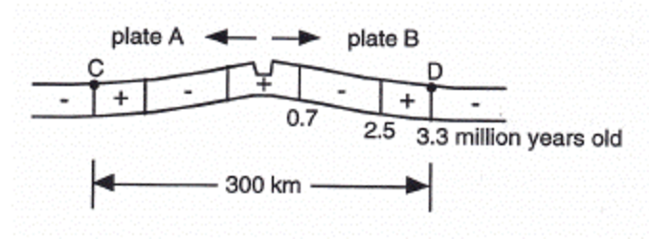
8. 3
9. 4
10. 7

3. List the order of colouring in magma as it begins to cool.

1. Orange -> red -> yellow -> black -> white.
2. Red -> white -> orange -> yellow -> black.
3. Black -> white -> orange -> red -> yellow.
4. White -> yellow -> orange -> red -> black.
5. 4. The supercontinent that was a single land mass of the current continents was called
6. Pangea
7. Gondwana
8. Laurasia
9. Eurasia

5. Name the two types of crust that form tectonic plates.

1. Transverse and continental.
2. Oceanic and diverging.

c. Continental and converging.

d. Oceanic and continental.

1. 6. Name the tectonic process that generates heat at the boundaries of the plate.
3. Seismic waves.
4. Subduction.
5. Circumduction.
6. Eruption.

7. In a convection current, the cooler denser fluid

1. Rises to the top
2. Sinks to the bottom
3. Stays on top
4. Stays where it is

8. Which of the following is an example of transform boundary?

1. East Africa ridge valley.
2. Mid-Atlantic Ocean ridge.
3. South Island of New Zealand.
4. Sundra trench between Australia and Indonesia.

9. Which scale is used to measure the magnitude of earthquakes?

1. Flux capacitor.
2. Amplifier.
3. Richter.
4. Multiplier.

10. What is pyroclastic flow?

1. The upward expulsion of lava during a volcanic eruption.
2. The varying constituents between tectonic plates.
3. A cloud of ash, rock and gas at about 500 degrees celsius.
4. Molten lava at 1500 degrees celsius.



**SEMESTER ONE 2016**

**Plate Tectonics Test:**

**ANSWER BOOKLET**

**NAME:**

**FORM:** **DATE:**

Multiple Choice Short Answer Total

**/34**

**/24**

**/10**

**SECTION ONE:** Multiple choice answers

Cross (X) through the correct answer.

|  |  |  |  |  |
| --- | --- | --- | --- | --- |
| 1 | a | **X** | c | d |
| 2 | a | b | **X** | d |
| 3 | a | b | c | **X** |
| 4 | **X** | b | c | d |
| 5 | a | b | c | **X** |
| 6 | a | **X** | c | d |
| 7 | a | **X** | c | d |
| 8 | a | b | **X** | d |
| 9 | a | b | **X** | d |
| 10 | a | b | **X** | d |

**SECTION TWO: Short Answer (25 marks)**

Answer the questions in the spaces provided.

**Question 11**

Define the following terms: (3 marks)

Magnetic striping:

**PATTERNS OF MAGNESIUM TRAPPED IN ROCKS ON EACH SIDE OF PLATE BOUNDARIES.**

Subduction:

**WHERE THE CRUST IS SINKING DOWN INTO THE EARTH.**

Primary Wave (P-wave):

**A LONGITUDIONAL SEISMIC WAVE THAT TRAVELS FAST THROUGH THE EARTH.**

**Question 12**

Give **TWO** pieces of evidence that support the following theories (4 marks)

Continental drift:

1. **SAME FOSSILS ACROSS DIFFERENT CONTINENTS**
2. **JIGSAW FIT**
3. **GLACIAL DEPOSITS**

Sea floor spreading

1. **YOUNGER ROCK AT MID OCEAN RIDGE, OLDER ROCK FURTHER AWAY**
2. **OCEANIC ROCK YOUNGER THAN CONTINENTAL ROCK**
3. **REVERSALS OF MAGNETIC POLARITY IN OCEANIC ROCK**

**1MARK (MAX 2 EACH) FOR ONE OF THE CORRECT ANSWERS**

**Question 13**

Use the diagram below to answer the following questions

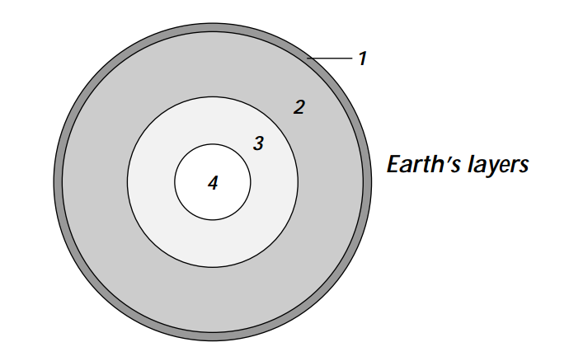

1. Label the layer of the earth from outermost to innermost (2 marks)

**CRUST, MANTLE, OUTER CORE, INNER CORE**

**0.5 marks each**

1. Show where the lithosphere is in the diagram (1 mark)

**ARROW BETWEEN MIDDLE OF MANTLE TO TOP OF CRUST**

1. What is the major difference between Layer 3 and 4? (2 marks)

**OUTER CORE IS FLUID LAYER OF NICKEL AND IRON (1)  
INNER CORE IS SOLID IRON AND NICKEL SPHERE (1)**

**Question 14**

Label **EIGHT** of the tectonics plates in this diagram (4 marks)



1. **JUAN DE FUCA PLATE**
2. **PACIFIC PLATE**
3. **COCOS PLATE**
4. **NORTH AMERICAN PLATE**
5. **CARRIBEAN PLATE**
6. **NAZCA PLATE**
7. **SOUTH AMERICAN PLATE**
8. **SCOTIA PLATE**
9. **AFRICAN PLATE**
10. **EURASIAN PLATE**
11. **ARABIAN PLATE**
12. **INDO-AUSTRALIAN PLATE**
13. **PHILLIPPINE SEA PLATE**
14. **ANTARTIC PLATE**
15. **OKHOTSK PLATE**

**EACH WORTH 0.5 MARKS EACH, MAX 4**

**Question 15** (9 marks)

There are **THREE** types of tectonic plate movement. State each type of plate movement, provide an example of a country/continent/land mass where it occurs and the resulting landscape changes as a result of the plate movement.

**1 mark for type of plate movement, 1 mark for an example where it occurs, 1 mark for resulting landscape. Examples include:**

* **Divergent boundaries: East Africa Rift Valley – creates rifts, ridges or volcanoes.**
* **Convergent boundaries: Nazca Plate colliding with the South American Plate – creates trenches and mountains.**
* **Transform: San Andreas Fault in California, North America – creates mountains and earthquakes.**